Test # | Description | PASS/FAIL
1 | Initialization and Select Circle | PASS
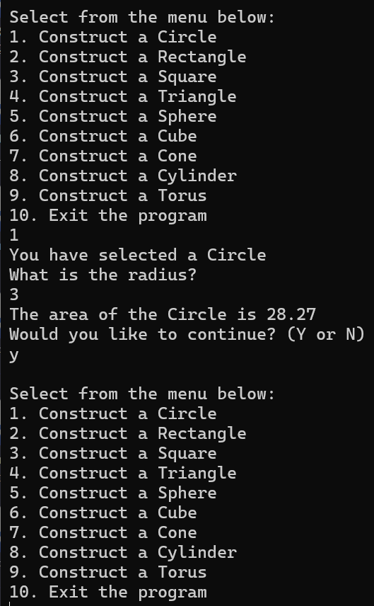
Test # | Description | PASS/FAIL
2 | Select Rectangle | PASS
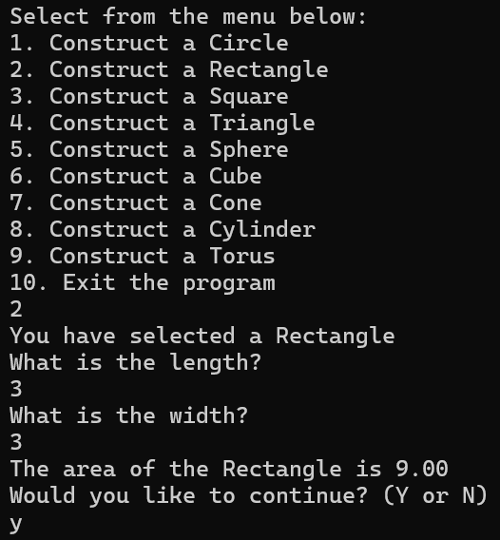
Test # | Description | PASS/FAIL
3 | Select Square | PASS
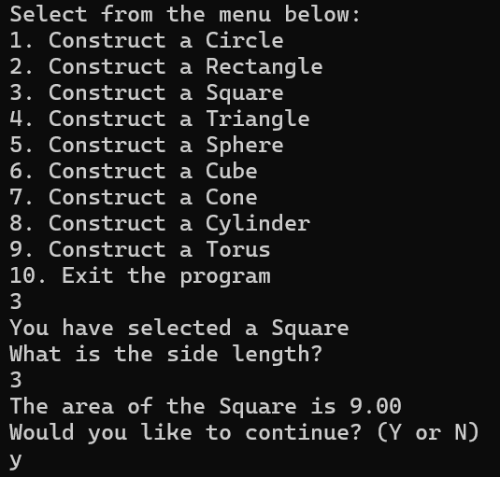
Test # | Description | PASS/FAIL
4 | Select Triangle | PASS
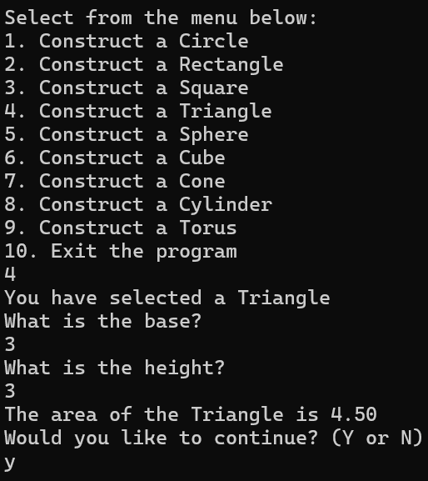
Test # | Description | PASS/FAIL
5 | Select Sphere | PASS
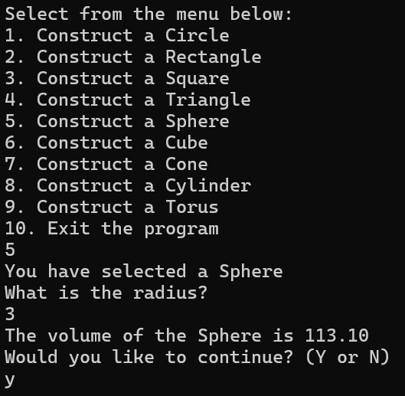
Test # | Description | PASS/FAIL
6 | Select Cube | PASS
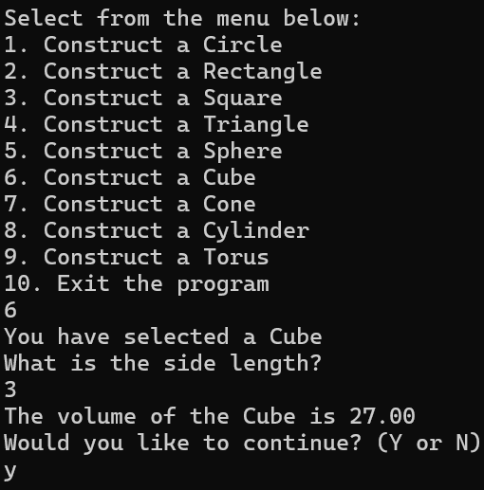
Test # | Description | PASS/FAIL
7 | Select Cone | PASS
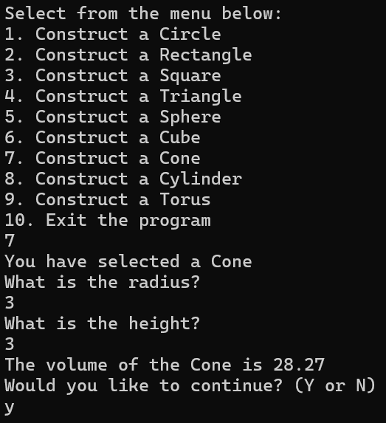
Test # | Description | PASS/FAIL
8 | Select Cylinder | PASS
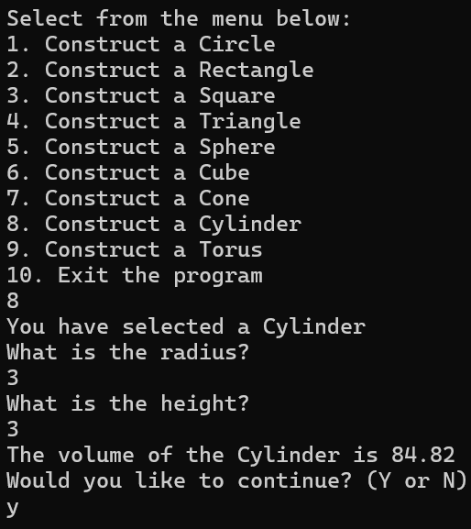
Test # | Description | PASS/FAIL
9 | Select Torus and error test | PASS
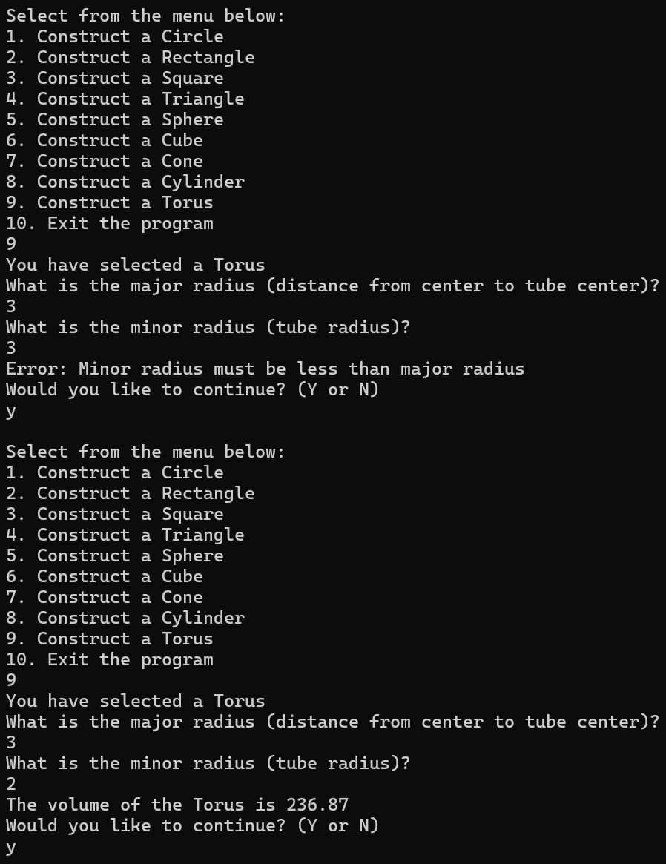

Test # | Description | PASS/FAIL
10 | Exit program | PASS
